Tianle Yuan
CS 550
October 27, 2020
Project 4

Name: Tianle Yuan
Email: yuant@oregonstate.edu
Project Number: 4
Project Name: Lighting
Web Link: https://media.oregonstate.edu/media/1_z35as3sj
Screen Captures：

Stationary light (green&white): Moving light (blue--in rocket tail): Moving light (red--in rocket head):
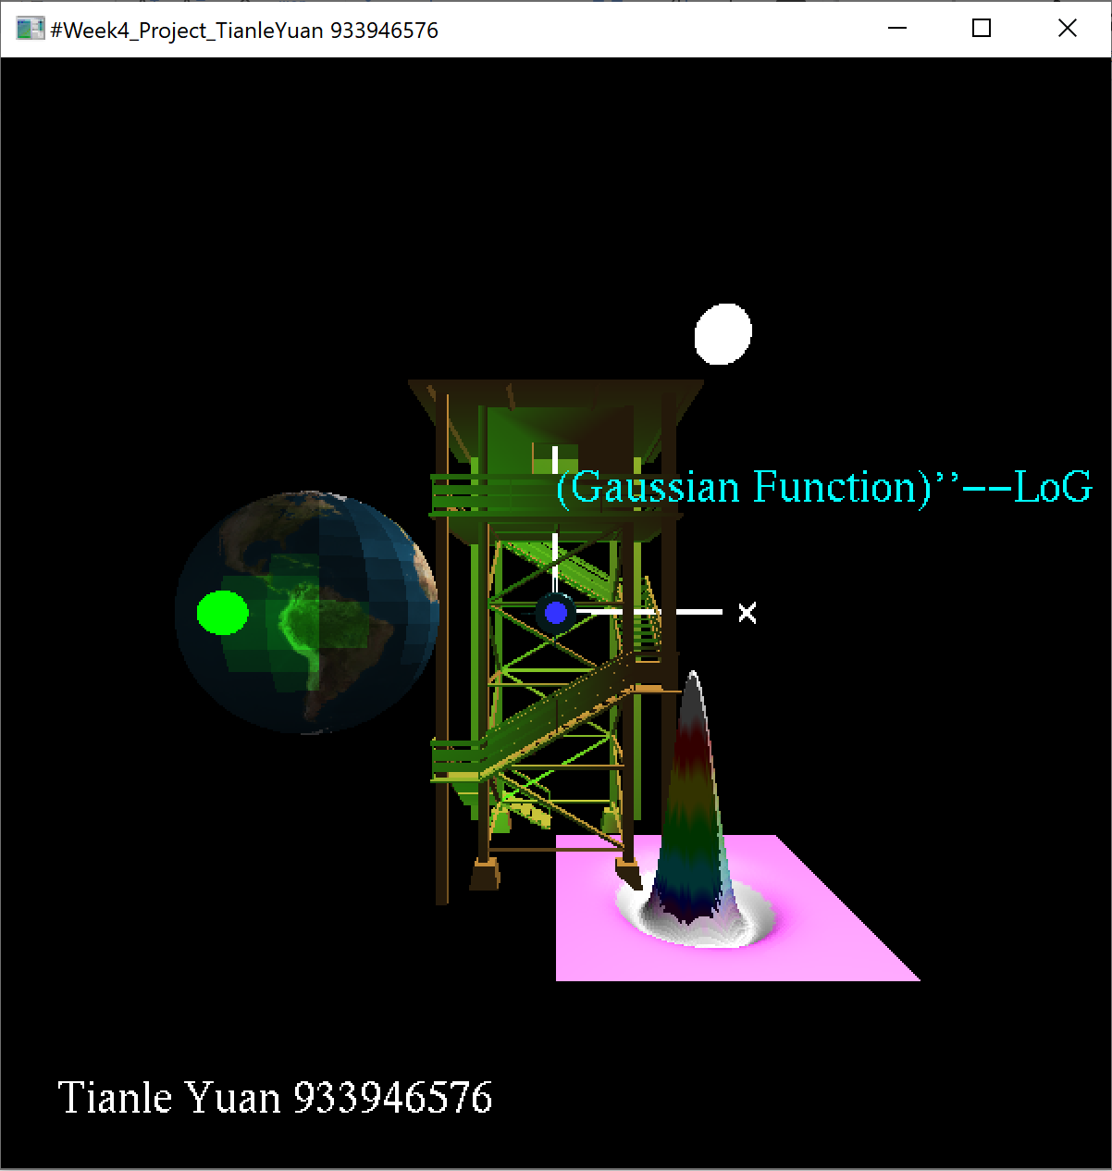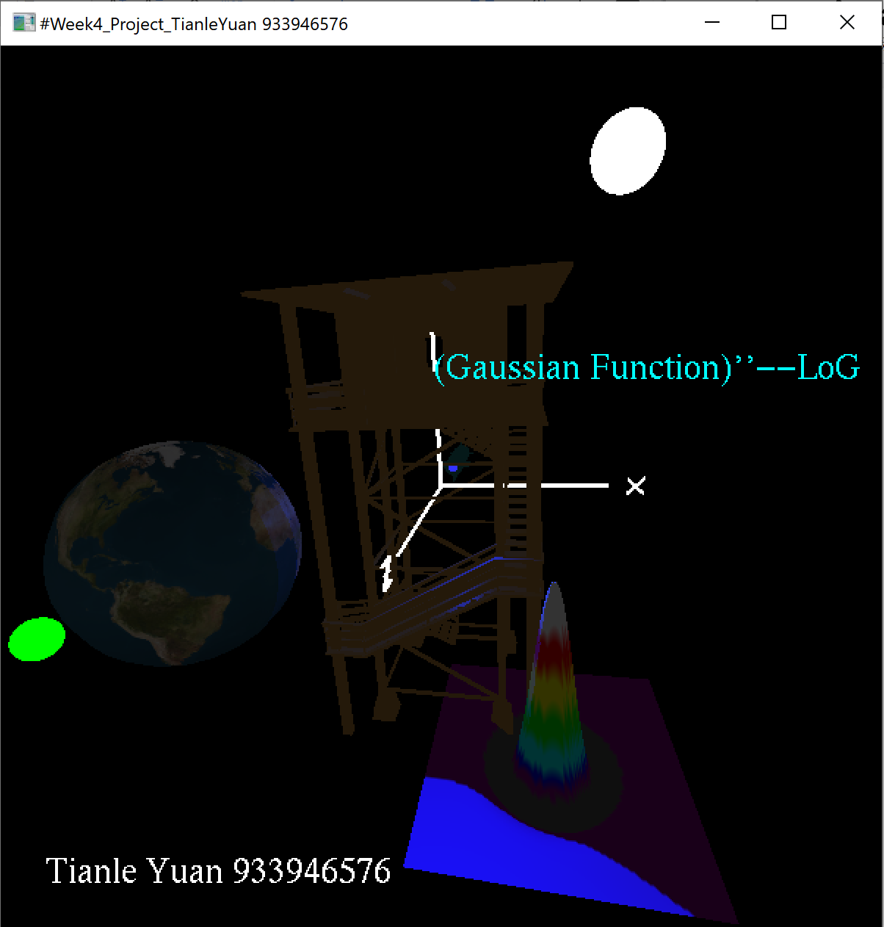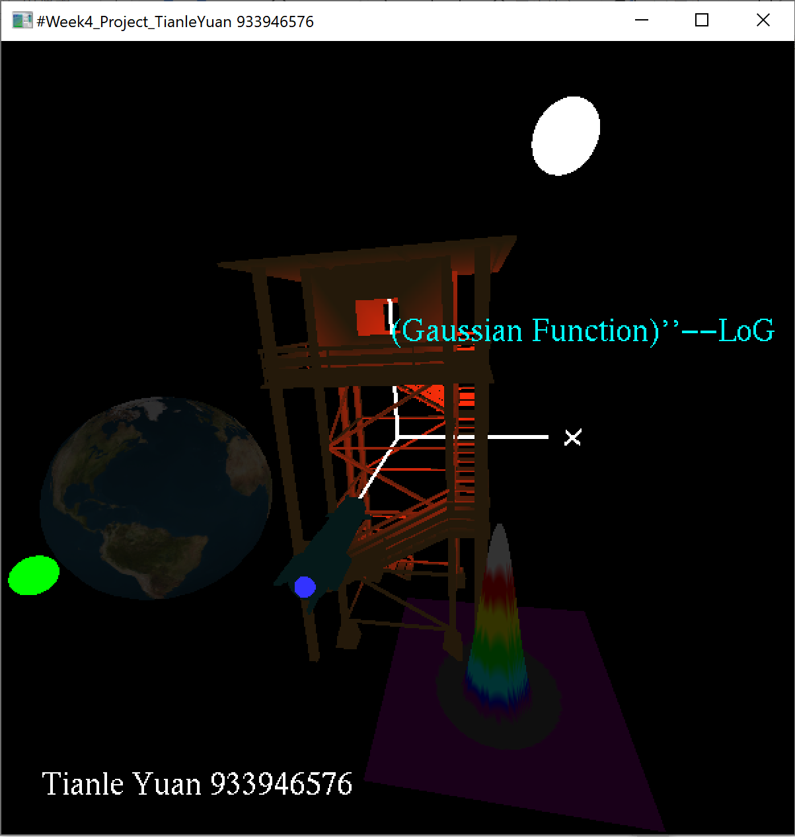

Point light (white): Spotlight (green, blue and red): [rocket is the moving object]
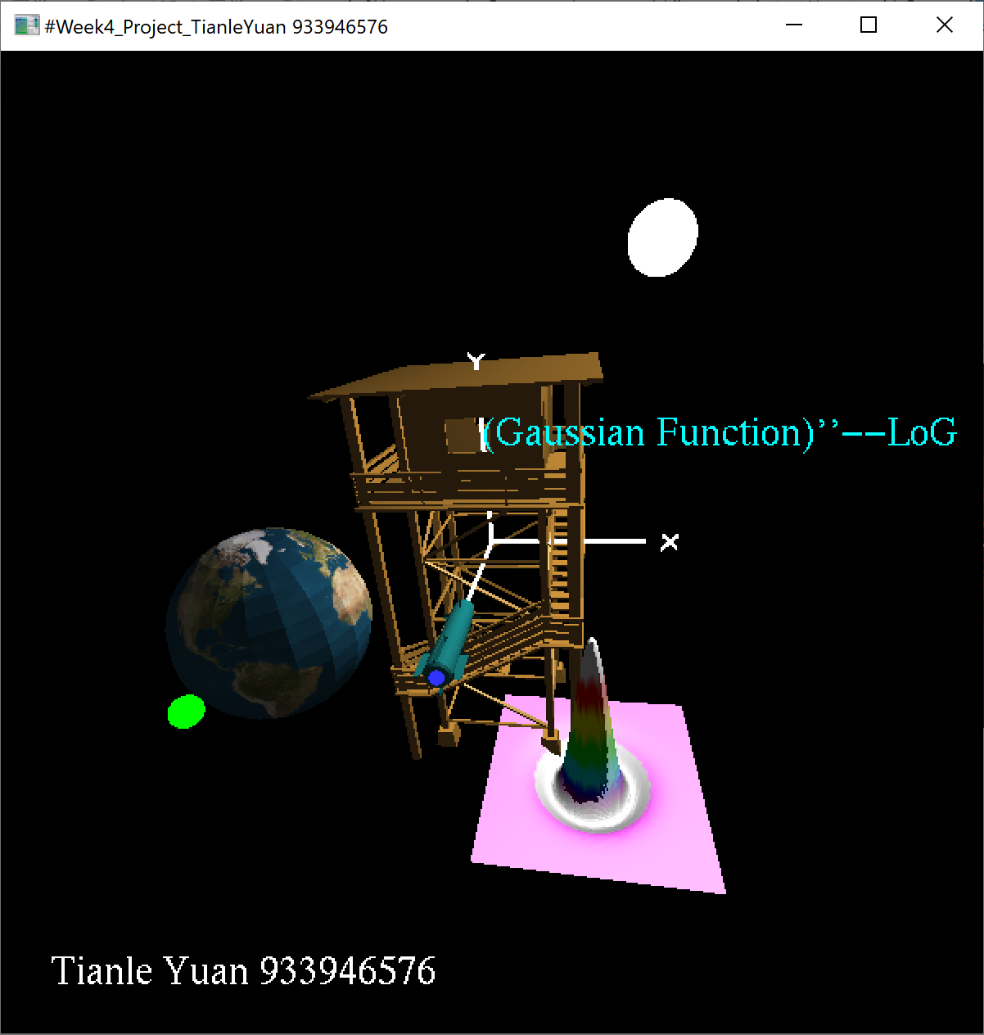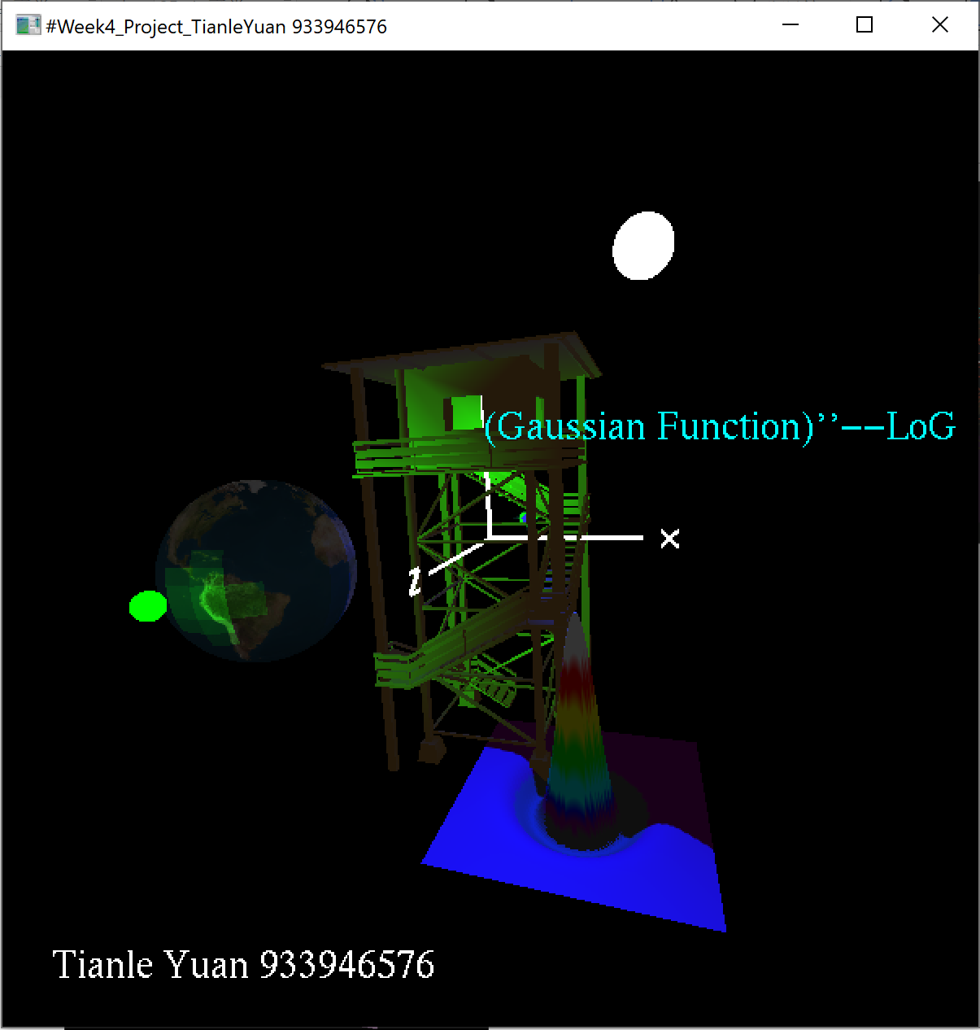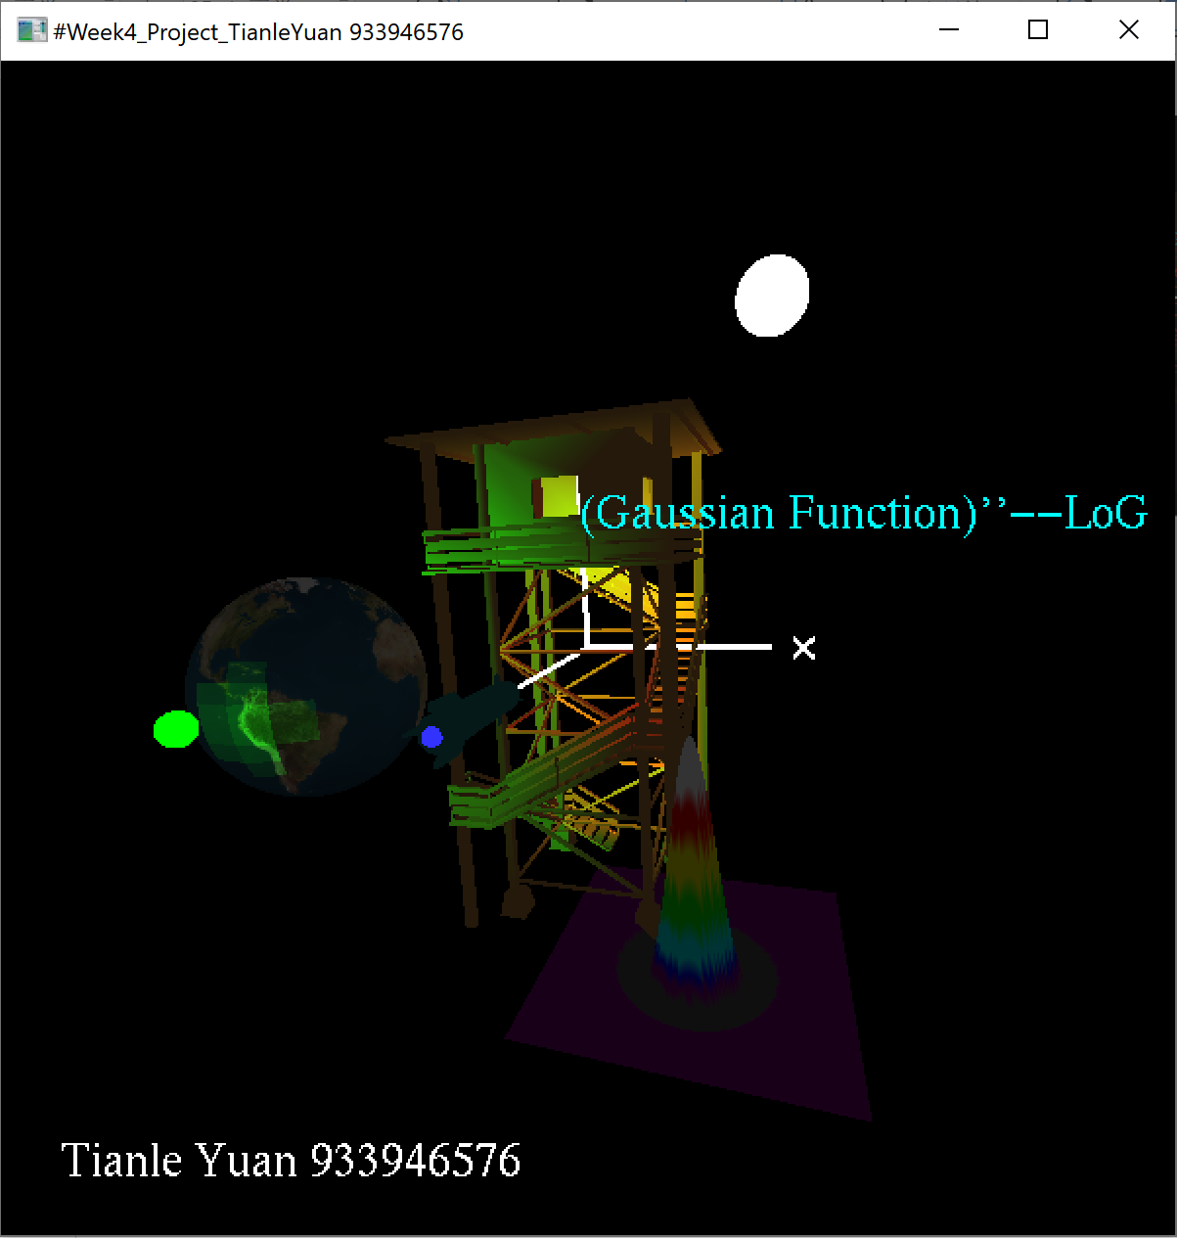

Shiny Objects(tower, earth and rocket): Dull Objects(Gaussian Function):
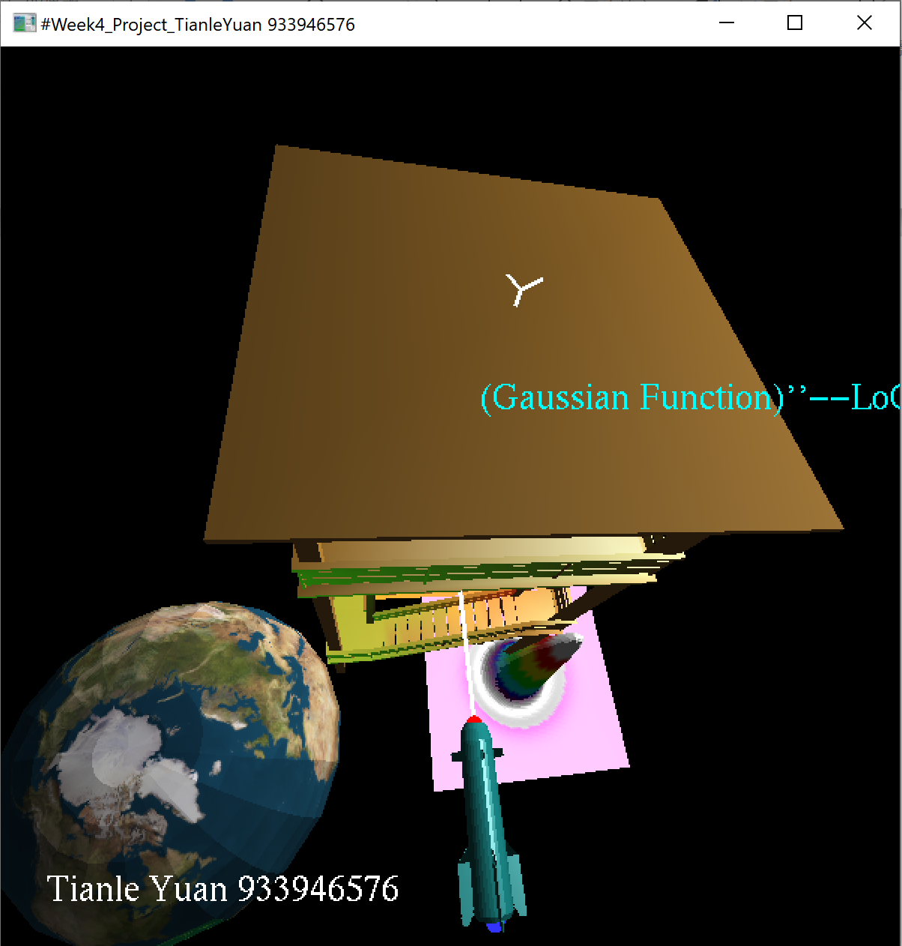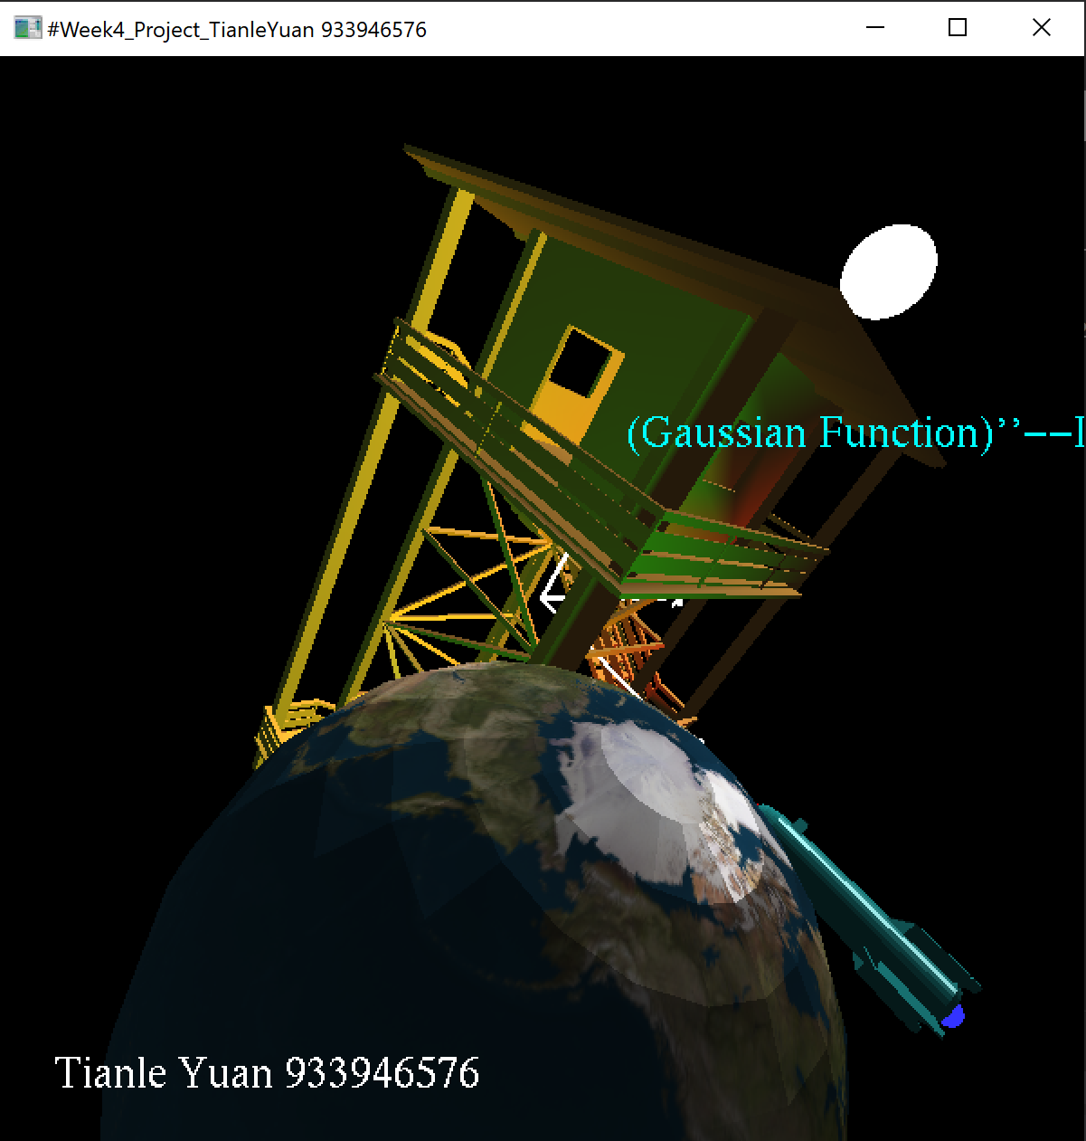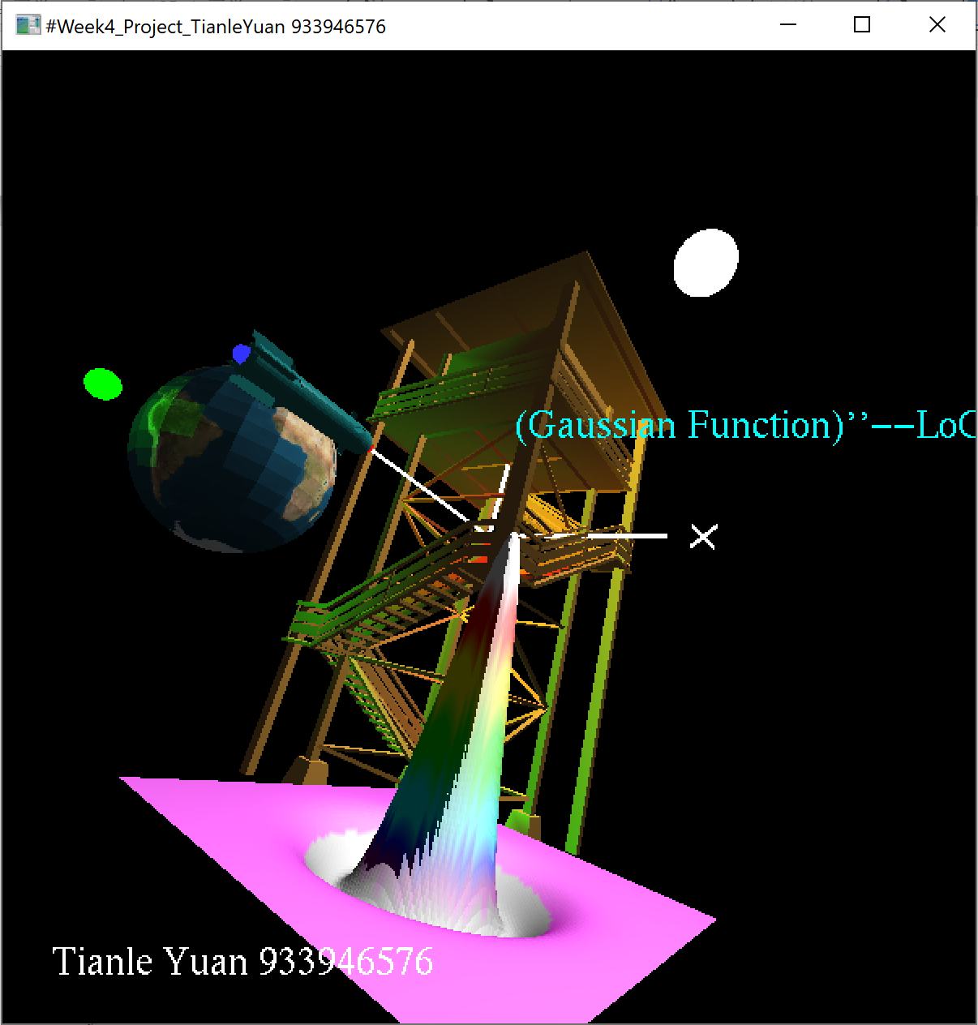
GL_FLAT(earth): GL_SMOOTH(tower, rocket and Gaussian Function):
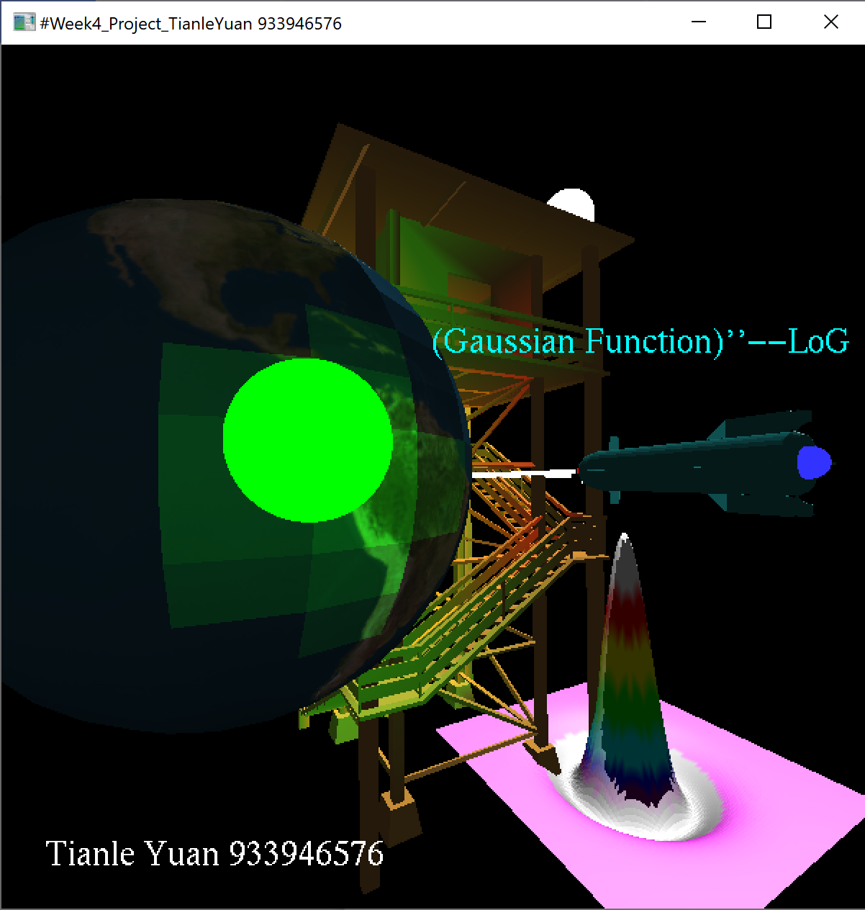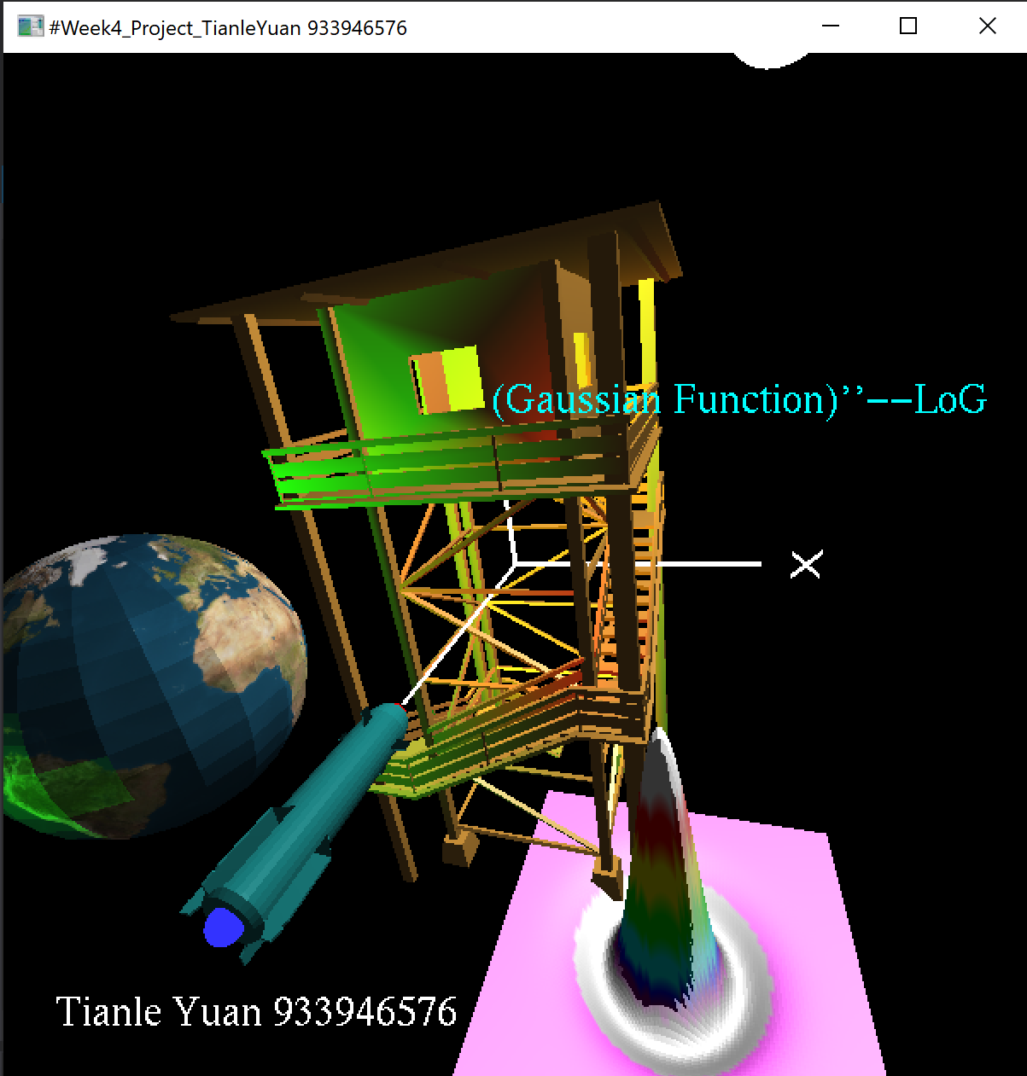
Small spheres (green,blue,red white): Extra Credit (earth with texture and lights):
